**EXPERIMENT -6**

**Title: Use of Inbuilt functions and relational algebra operation**

**Objective:** To understand the use of inbuilt function and relational algebra with sql query.

**NAME – Akshat Srivastava**

**BATCH – 2**

**SAP ID – 500123177**

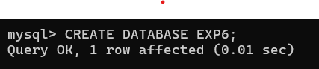

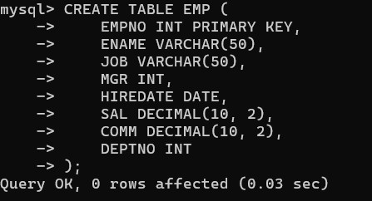

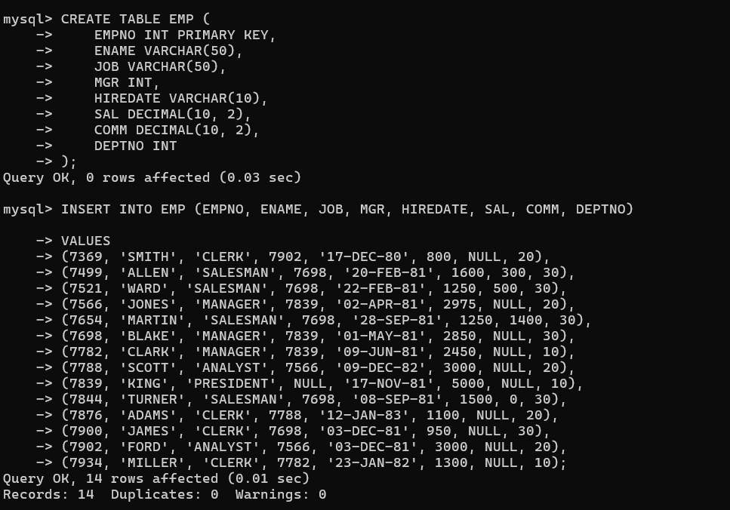

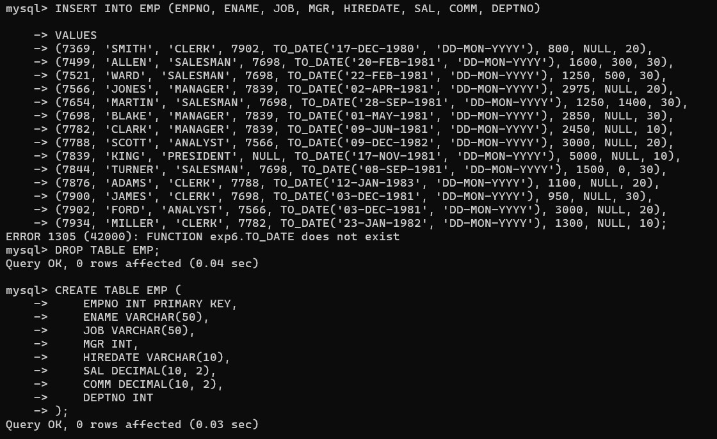

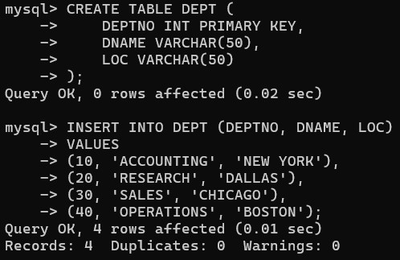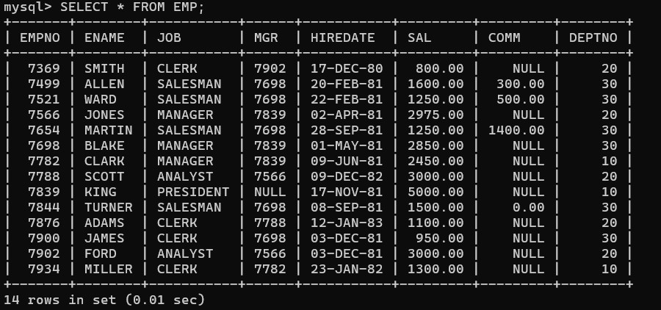

1.

Retrieve average salary of all employees.

2.

Retrieve the number of employees.

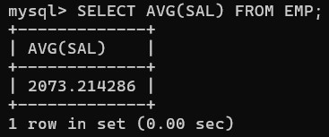

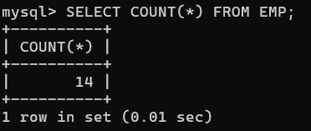

1. Retrieve distinct number of employees.

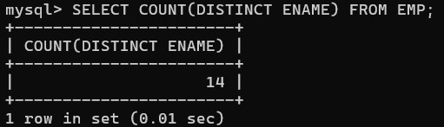

1. Retrieve total salary of employee group by job.

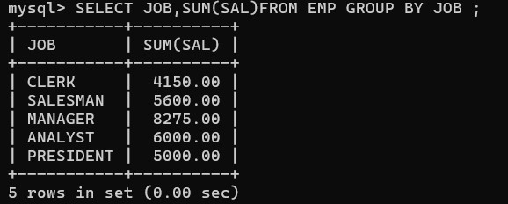

1. Display the employee information with maximum salary.

6.

Find

the highest paid employee in department 10.

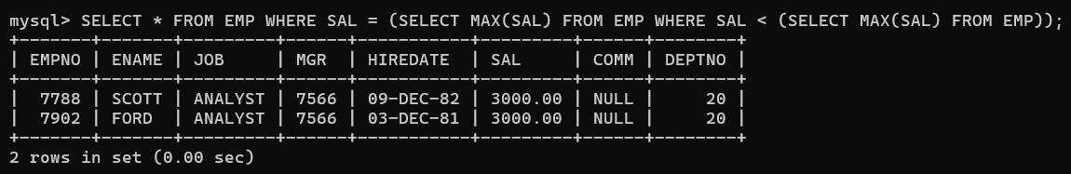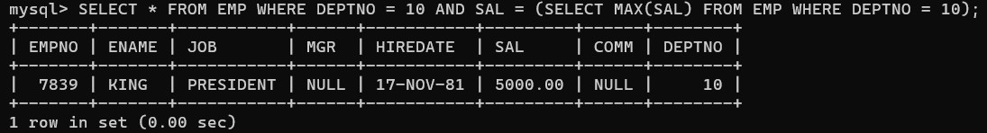

1. List the emps whose sal is equal to the average of max and minimum.



1. List the emps who joined in the company on the same date.

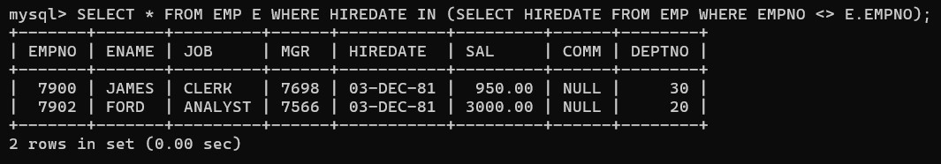

1. Display the employee names in upper and lower case.

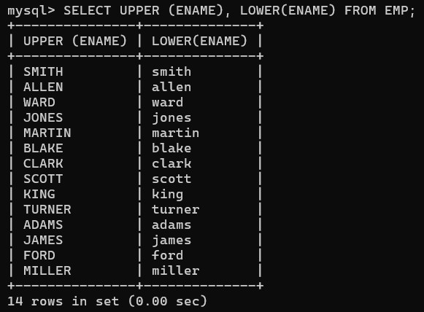

1. find the date of 3 days later from hiredate.

